Fulfilling a dream
Mohamedally and Maniben Rattansi Educational Trust

A Dream Fulfilled for Mohamedally and Maniben Rattansi

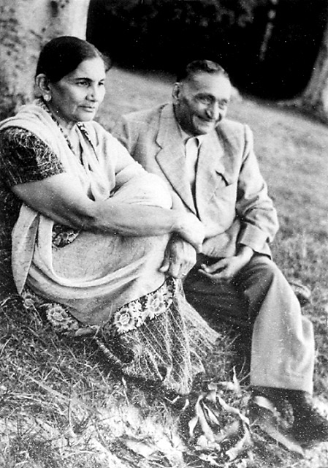
Maniben and Mohamedally Rattansi at Masaka Tea Plantation (1953)
Founders of the Mohamedally and Maniben Rattansi Educational Trust

If God has given you something more than you need,
whether it is money or talent, you are only a trustee. Use what you need, and give the rest to the people around you.

Hassanally Rattansi

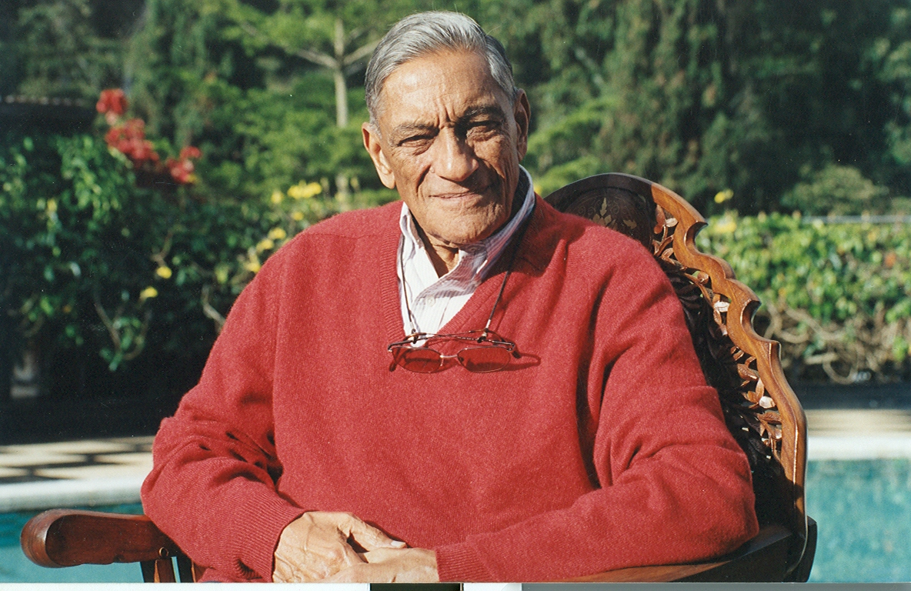

Dr. Hassanally Rattansi, (1921-2003); D. Litt. University of Nairobi (1988);
D. Litt. Kenyatta University (2002); Silver Star (S.S.) of Kenya (1998)

Table of Contents

Preface i
Dedication ii
Acknowledgment iii
India and East Africa at the Turn of the Century 1
Mohamedally Arrives in Nyeri 3
A Growing Family 6
Schooling in Colonial Days 12
The Move to Nairobi 14
Retirement in Uganda 15
Mohamedally Rattansi’s Ideals and Philosophy 17
Dr. Hassanally Rattansi 21
Establishment of the Mohamedally and Maniben Rattansi Educational Trust 36
What is the Mohamedally and Maniben Rattansi Educational Trust? 39
Vision of the Trust 40
Aims and Objectives 40
Benefiting all the People of Kenya 40
Continuing Expansion of Trust Income 43
Future of the Trust and of Kenya 44

Preface
Mohamedally Rattansi was a humble man who never sought publicity for himself, not even when he founded a large Educational Trust. Only at the insistence of the founding Directors appointed to run the Trust was he persuaded that a formal ceremony be held for him to consign the property deeds to the then Governor of Kenya, Sir Evelyn Baring.

Since the demise of Mohamedally Rattansi the founder in 1957, the Trust has carried on with its work quietly and unobtrusively. The Trust has grown so rapidly in the past few years and touched so many lives that the directors feel that the time is ripe for compiling a historical account of the Trust. It was the founder’s wish that the Trust be owned by the people of Kenya. Kenyans have a right to know its story. That is the reason why this book has been compiled, to coincide with the Trust’s fiftieth (50th) anniversary.

It is also in recognition of this great contribution to the people of Kenya that Moi University decided to publish this book, a task it feels honoured to perform. Moi University would also like to express gratitude by the same gesture, to the Mohamedally and Maniben Rattansi Educational Trust for the support extended to the institution through bursaries for needy students and a substantial purchase of Library information materials.

Moi University would like to join other Kenyans in congratulating the Mohamedally and Maniben Educational Trust as it marks its Golden Jubilee.

Prof. David K. Some,
Vice Chancellor,
Moi University.

Dedication
This story is dedicated to five very precious people in my life.

To my husband and mentor, Dr. Hassanally M. Rattansi, who sat patiently with Cynthia and myself, for many hours until the Rattansi story came to fruition. Your sense of humour and delightful tales during this time will always come to the fore. Thank you very much for all your love, guidance and values handed down to us all as a family. Your presence will always be felt very strongly by us. Your love for the human race and all the beautiful things nature has bestowed upon us will always be appreciated and emulated. You are our guiding light. Thank you for this eternal beautiful lamp you have lit for us. Your generosity and love towards the people of Kenya will never be forgotten. Thank you for sharing this cup of life from which you have drunk with us. Thank you for teaching us to give unconditionally. How right you were in teaching us that there is no joy like giving!

To my father-in-law, Mohamedally Rattansi, and my mother-in-law Maniben Rattansi, thank you for the vision you had for this our country Kenya, which you both loved immensely and which was your home. I know the fulfilment of this dream will carry on forever and aye. Thank you for all the joy we receive in carrying on this noble work.

To my mother and best friend, Radha Punjwani, thank you so very much for all your love and your wise teachings which will always be pearls of wisdom to me. Most of all, thanks to my father, Pessumal, for being my pillar of strength. Although the Good Lord beckoned you when we were still in our very tender years on earth, we still remember you for being the kind, loving, thoughtful and generous father you were and will always be.

Mrs. Vijoo H. M. Rattansi
Chairman
Rattansi Educational Trust

Acknowledgment

To Moi University a very, special “THANK YOU” for being instrumental in publishing The Rattansi Educational Trust story. True friends are rare! Thank you for being ours.

To Professor David K. Some, Vice Chancellor of Moi University, a very big thank you for giving me that much needed push to turn the Rattansi story, “Fulfilling a Dream” into reality on paper. Your kindness, patience, encouragement and readiness to help was most definitely appreciated.

To Professor Margaret J. Kamar of Moi University, thank you so much for playing a role in all this.

To Professor Godfrey Muriuki of University of Nairobi and his wife Margaret, thank you for all the encouragement.

To Dr. Joyce Agalo of Moi University, a very big thank you for all the patience, a lot of vigorous hours of hard work and umpteen trips to the Rattansi offices that you had to make to help in realizing this dream on paper.

To Karen Jeruto of Moi University, many thanks for all the patience and hard work put into the story.

To Cynthia Salvadori, a big thank you for spending time with Hassanally and myself and then churning out a lovely story on the Rattansi Educational Trust.

To Charles and Margaret Njonjo for always being by my side and for that unending faith and words of encouragement.

To my sisters-in-law Zarina Nanji, Kulsum Mohamed, Roshan Kassam Kanji and her husband Hassan Kassam Kanji and Shirin Sondhi and her husband Jagdish thank you so much for your never-ending encouragement.

To my brother-in-law Prof. Piyo Rattansi, thank you for your contribution.

To my two very precious sons Riaz and Imran, thank you very much for having so much faith in me and always being there for me with all your thoughtfulness, love and care.

To my brothers Tulsi and Jimmy, my sisters Bhagi and Chandra, and my sister-in-law Sheila a very big thank you for all your love and being there for me always.

To Rafiq, Rehana and Nadya thank you for being there.

To Francesca Njage, my secretary, many thanks for her invaluable running around.

To my many friends, whose kind gestures and words have kept me going, thank you for being there.

Last but not least to my Board of Directors at the Rattansi Trust, thank you for always being by my side.

Mrs. Vijoo Rattansi

India and East Africa at the Turn of the Century
The history of the Mohamedally and Maniben Rattansi Educational Trust can be traced back about 150 years ago to the coming of Mohamedally Rattansi to Kenya. Mohamedally Rattansi was born in 1882 in Chavand, a village in Kathiawar, India. His father Rattansi Nanji, a Shia Ismaili, owned a small shop selling basic merchandise, such as salt, sugar, and dates to villagers and neighbouring farmers in India.

Sandwiched between the Great Raan (desert) of Cutch and the coast, Kathiawar suffers aridity and an extremely varying rainfall. A prolonged drought, which plunged the rural community into a state of crisis, occurred in that part of Northwestern India when Mohamedally was a boy. Crops failed, food was scarce, and the inhabitants lacked money to buy; even, bare necessities were lacking. Rattansi Nanji, did not only make money but he also lost it as well, through supplying his neighbours on credit. When his son, Mohamedally, began to earn an income, he always sent some of it home to sustain his father and his altruistic shop, however small the amount was.

Arising from the effects of drought and famine in Kathiawar, there was high migration from rural to urban areas. One of Mohamedally’s uncles had already migrated and settled in the vast city of Bombay. When barely in his teens, Mohamedally left his village and moved to Bombay to join his uncle in search of a job to better his life.

So many people were continuously flooding into Bombay causing the jobs to become scarce. Mohamedally learnt, however, that there were opportunities in British East Africa (Kenya was part of it). In 1897 the British began to build a railway line from Mombasa to Lake Victoria to open up the hinterland for trade and administration. A great number of Indian indentured labourers, eventually numbering about 32,000, were recruited to build the line. The work started in Mombasa and soon, the small Swahili port became a bustling town. Mohamedally’s cousin, Javer Kassam, had already migrated there and ran a small shop.

In 1899, the railway reached the swampy area which the Maasai called ‘the place of cool waters’, or Nairobi, and a town was beginning to develop. At the same time, Asian traders, having established themselves on the East African coast, were following the rail line and penetrating deeper into the hinterland. It was those intrepid pioneers who introduced the exchange economy as the British administrators raised the flag of the Empire and established small administrative centres or bomas.

The Asian traders set up small shops, known everywhere as dukas (from the Indian word dukan). The first shops were no more than tents, sheets of canvas propped up on poles. They were soon replaced by thatched huts, and later by corrugated iron-sheet buildings, with the shop in front and living quarters at the back. As Sir Winston Churchill wrote: “It is the Indian trader, who, penetrating and maintaining himself in all sorts of places in which no white man could earn a living, has more than anyone else developed the early beginning of trade (in East Africa) and opened up the first slender means of communication.” Such were the humble beginnings of every town in the hinterland.

The most enterprising of the Asian entrepreneurs was a Shia Ismaili by the name Seth Alidina Visram. By the turn of the century, Visram had established a chain of dukas stretching from the Coast to the Nile. There was a great demand for young and adventurous fellow Ismailis to steward the shops. Seeing this opportunity, Javer sent a message to his young cousin Mohamedally, telling him: to ‘Come to Africa. I shall help you find a job.’

Mohamedally’s initial intention was to go to Bombay to find a job. However when his cousin called him to Africa, he departed without informing his parents. His parents were therefore, worried and his mother fasted for one month wondering where her son was. Finally, word arrived from Visram that their son Mohamedally was in Kenya with him.

Mohamedally Arrives in Nyeri
Mt. Kenya

Just at the turn of the century, young Mohamedally boarded a dhow from India and docked at the old harbour in Mombasa. With Javer’s help he got a job with Alidina Visram. The firm sent him to run a shop in the newly established administrative centre of Nyeri in Central Kenya. It lay in the heart of Kikuyu country, in a valley nestling between the ranges of the Aberdares and Mount Kenya. He arrived there after journeying several days from Nairobi through Naivasha over the Aberdares, with the porters who had carried his trading goods. They walked along footpaths and animal trails, covering about ten miles per day, resting each night in a forest clearing. He was to make the journey on foot dozens of times over the years until the advent of motor vehicles and roads.

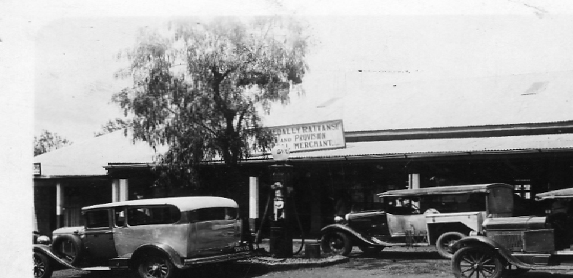

Shop in Nyeri with Petrol pump outside

His first customers were Kikuyu farmers living around the new boma. As he got to know the surroundings, he made trips farther afield and traded with the Wandorobo hunters inhabiting the dense forests of the Aberdares.

Barter remained the predominant form of trade at the time, although the Indian rupee was already officially in circulation. He bartered beads, salt, sugar, amerikani (cotton cloth) and blankets with the Wandorobo hunters, for ivory, rhino horn, hides and skins in exchange. He then transported these goods to Nairobi himself by portage, and returned with a replenished stock of trading goods. So successful was the barter trade that he soon employed about a hundred porters, each carrying the standard load of 18.16kgs of merchandise. (Strict rules already regulated the maximum weights porters could carry, and the wages they were to be paid.)

After Mohamedally had been in Nyeri for several years, Seth Alidina Visram died. His now expansive business empire (he was known as the ‘uncrowned King of Uganda’) was inherited by his son Abdulrasul, but it soon began to crumble. Mohamedally joined forces with a fellow Indian, Osman Allu, who had managed a shop in neighbouring Fort Hall (Murang’a), and they bought up the Nyeri shop in partnership. It then operated under the name of Osman Allu.

Photo of Osman Allu Shop in Nyeri

In the meantime, European settlement increased in that area by leaps and bounds. Mohamedally and his partner Osman gave up barter with the indigenous people and now turned to satisfy the needs of these new settlers. Their profit margins in those days remained infinitesimal. For instance, when they sold sugar scoopful by scoopful out of a sack, the empty sack was the profit. Slowly, however, they made a success of the business. They extended the shop-cum-house, and built a mill for grinding maize on the Chania River where it flows to Nyeri. Mohamedally acquired several properties of his own in the growing township and in neighbouring Karatina too.

The partnership continued to prosper. Mohamedally had a flair for business and looked after the customers, while Osman Allu superintended the transport - at first ox teams and wagons – and later the mill. A setback came in the 1920s when the settlers plotted rebellion and threatened not only to overthrow the colonial administration but to `drive all Indians into the sea’. The partners took the precaution of sending their families temporarily to India, while they kept the business going with the help of loyal employees.

In 1930, they dissolved the partnership and went their separate ways. Each established a business under his own name. Mohamedally proceeded to become one of Nyeri’s most prominent Asian merchants. He was a member of the Town Council, which later named a street, where he had a ‘shamba’ property, after him. (The ‘Rattansi Street’ sign, however, has vanished over the years and has not been replaced.)

A Growing Family
Standing from left to right
Badru, Haider, Roshan, Hassan, Sultan
Seated from left to right
Shirin, Mohamedally Rattansi, Kulsumben, Pyarali, Malekben, Mrs. Maniben M. Rattansi, Zarina (1942)

In spite of a tragic initial setback, the young Mohamedally’s family prospered. A few years before he left home, Mohamedally was ‘married’ to Maniben, a girl from a nearby village. It was a traditional Indian child-marriage as he was then twelve, and his bride only ten. They had not, of course, lived together. After settling in Nyeri, Mohamedally wrote to the girl’s parents asking them to send her to join him in Africa. Mohamedally’s uncle, Javer, would arrange to meet her when the ship docked at Mombasa.

Javer Kassam had never set eyes on the girl, and many questions ran through his mind. How was he to recognise her? Maniben later used to tell her children how she anxiously waited at the dockside with growing despondency, watching all the others being met and moving off, until she alone was left there. She felt utterly abandoned. Only then did a man approach and asked her if she was Maniben. By elimination, Javer had inferred that this forlorn girl must be his nephew’s bride. And he had been proved right.

Javer sent Maniben to Nairobi by train. There, the young man she had married and now only half-remembered met her. She then accompanied him on the first of her many trips through the forest and mountain ranges to Nyeri.
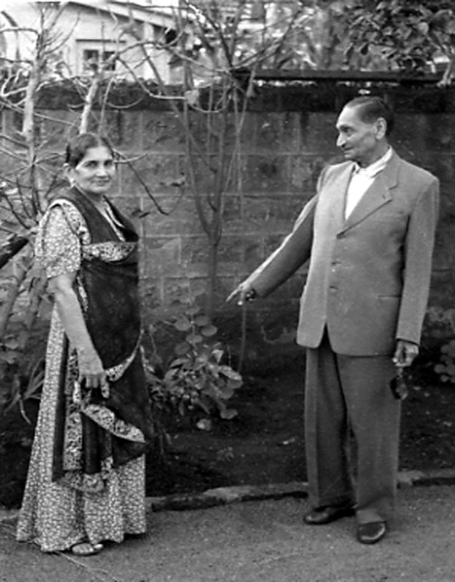

Maniben and Mohamedally Rattansi outside their home in Nairobi (1953)

In due course, she gave birth to a girl, delivered (as all of their family were) by an African midwife. When the little girl was only a few weeks’ old, Mohamedally undertook a trading trip on the Aberdares. He took his wife and baby with him. Mother and child travelled comfortably enough in a doli, which was a hammock slung on poles, carried by the porters. They spent a night in the Aberdare forest with his Wandorobo barter customers. The night grew bitterly cold and the child fell suddenly ill and died during the night. The grief-stricken parents buried their first child there, in the Aberdares. Maniben never forgot the name of the area (Kiandongoro) and Mohamedally never used that route again.

Undaunted by this setback, the Rattansis went on to raise a large family, indeed one that may seem incredibly large by today’s standards. They bore five sons and five daughters. They were Malek, Haiderally, Kulsum, Hasanally, Badruddin, Roshan, Sultanally, Pyarally, Shirin and Zarina. Thus Mohamedally may appear to have pioneered Kenya’s population explosion too! Family patterns were quite different from the present one. Manpower was scarce. ‘Each child brings one mouth - and two hands’ enshrined the folk wisdom of the day. Infectious and epidemic diseases, many now eradicated, kept life expectancy at birth depressingly low. That all of the children, except the first-born, survived childhood was by medical standards of those days, the exception rather than the rule. Indeed, it was almost a miracle.

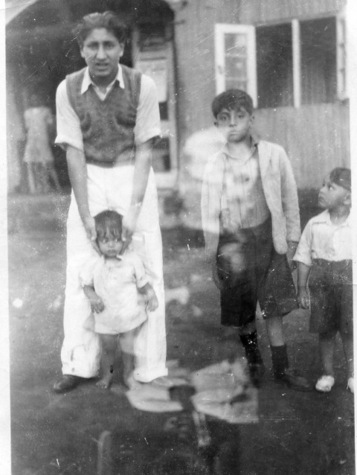

Left to right
Pyarally (baby), Haiderally ,Badrubhai and Sultanally in 1930
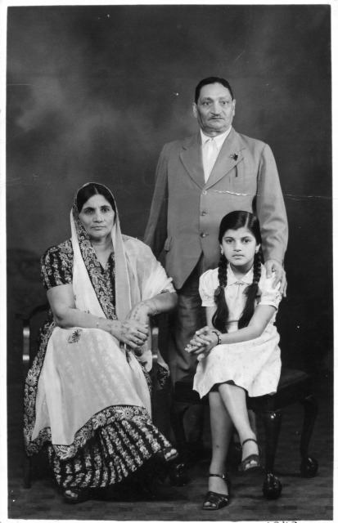

Standing: Mr. Mohamedally Rattansi
Sitting: left to right Mrs. Maniben Rattansi and daughter Zarina

So the Rattansi family grew up in Nyeri, in the shadow of Mount Kenya, except for a brief interlude between 1923 and 1926, when Mohamedally sent the family (five at the time) to India when threats of settler rebellion made him uneasy. How Maniben was able to feed the family has remained a mystery to her children to date. Her budget was shillings 20/- per month, out of which she had to feed not only a growing and hungry family, but also a staff numbering four to five.

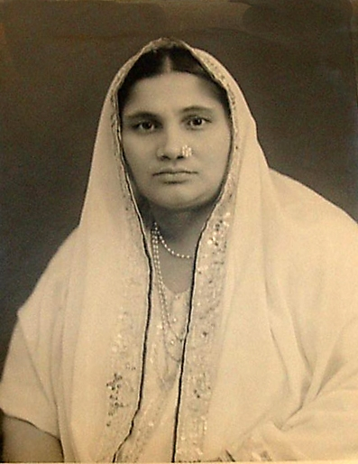
Maniben Rattansi (1886-1965)

As the saying goes that behind every successful man, there is a very hard working woman, this is very true of the Rattansi family. Maniben was one such woman.

Equally, Maniben had lived a full life in Kenya. At Nyeri she had learnt Gikuyu from Kikuyu women, vegetable and produce hawkers and her domestic servants. On top of this, she had added a little English. Pretty and well dressed, she kept an immaculate house in which she welcomed many a visitor. She used to host so many visitors that meals had to be eaten in shifts! Above all, she embraced visitors of all races. For example, Indian as well as African children would romp around freely in her compound, which was unusual in those dark days of racial segregation. Moreover in Nairobi, she was Chairperson of the Ismaili Women Committee, which engaged in charitable work.

Schooling in Colonial Days

Mohamedally Rattansi had only enjoyed a few years of formal schooling, up to about the third or fourth standard in a village school. He recalled practising reading by the post-office lamp. The only language in which he was proficient when he arrived in Nyeri was Gujarati. He picked up Kiswahili, of course, and also Kikuyu. When he decided to change his business and supply provisions to European settlers in Nyeri, he realised that a knowledge of the English language was indispensable. He persuaded a friendly postmaster, a Mr. Wilcock, to tutor him, and subscribed to an English-language Indian journal, The India Review. Thus he became proficient in the English language. He read extensively, across a wide range of literature, from the Indian epics, poetry, and biographies, to religion and philosophy. He had a finely developed sensitivity to language, and wrote family letters and voluminous diaries in an elegant Gujarati style. He taught himself Sanskrit and many years late,r encouraged the youngest two sons to attend Sanskrit classes after school to improve their command and appreciation of Gujarati. He must have been one of the few in Kenya at the time to own a complete set of the Encyclopaedia Britannica. A self-taught person in the main, he placed the highest premium on education. He wanted his children to obtain the best education he could provide for them.

In those days, education was structured on racial lines, with designated schools for Europeans, Asians, Arabs and Africans. The amount allocated per head by the colonial government to students from each racial group varied widely. The government made no provision for Asian schools in the rural areas. In any small township, Asians typically clubbed together to hire a teacher or two from India, and set up their own schools. Often a leading merchant would provide rooms in his house to serve as classrooms. Only when enough Asian families had moved into a town was the community large enough to contemplate putting up a proper school. Education at such rural schools typically went up to about Standard Three. If the pupil wished to continue into secondary education, he or she would be sent to Nairobi or a larger town in order to do so.

In Nyeri, the Asians were in the initial phase of just such a development. For many years, Mohamedally’s deep concern for education made him set aside part of his properties. He availed the shamba on what later came to be named Rattansi Road, for housing the school. This was a corrugated iron-sheet structure with cement floors. It included teachers’ quarters and accommodation for servants besides the classrooms. The desks and benches were made by local carpenters.

Haiderally, one of the sons, had to leave school at the tender age of thirteen to help Mohamedally run his business after he dissolved his partnership with Osman Allu. Hassanally was however luckier. At the age of ten, after completing whatever schooling Nyeri could offer, he came to Nairobi as a boarder and attended the Government Indian Senior Secondary School now called Jamhuri High School. This school prepared students up to the London Matriculation standard.

The youngest three members fared best academically. All three were able to go to England for further education. Shirin, Zarina and Pyarally were the lucky ones. Shirin chose photography as her career. Pyarally, was to enjoy a distinguished academic career abroad. After obtaining his B.Sc and Ph.D at the London School of Economics, he made the history of science his specialty. He was successively: Leverhume Research Fellow and lecturer at Leeds University; a Visiting Professor at Chicago University; a Fellow of King’s College, Cambridge; and a Visiting Professor at Princeton University. In 1971, he became the youngest person appointed to the professorship in the History and Philosophy of Science at the University of London and head of department in that subject at University College, London.

Another member of the family with a successful academic career was Dr. Ali Rattansi, the son of Haiderally. He studied Economics at Manchester University, obtained his Ph.D. at Cambridge University, was appointed a lecturer in Sociology at Leicester University and is now at the City University in London. He has a particular interest in Race and Education and has been associated with the Open University in the United Kingdom, a leading institution in distance education. Both Pyarally and Ali Rattansi feel that the value placed by Mohamedally on literature and learning provided a profound formative influence on each of them, even though they represent two different generations of the family.

Love for education and learning was something that the family imbibed from Mohamedally. There were many other preferences and values he imparted on his children.

The Move to Nairobi

In 1936, one of his sons, Hassanally, passed the London Matriculation Examination which was the passport to university entrance. Being good at chemistry, he was keen to go to the United Kingdom to study medicine or pharmacy. However, it was not to be. His younger brothers and sisters were outgrowing the small Nyeri Asian School (now housed in its own premises). Hence his father decided to move to Nairobi so that they could continue with their schooling and as such Hassanally had to let go off his dream for that movement to further his studies in the United Kingdom.

Hassanally and his elder brother Haiderally were left with the responsibility of taking care of the Nyeri business. Their father moved to the capital city and founded a large grocery and provisions store on the premier avenue, Government Road (now Moi Avenue). A young man, Madatally Manji, accompanied him from Nyeri. Madatally eventually founded a vast Kenyan enterprise, the House of Manji. At that time, he had been staying with the Rattansi’s as one of the family and worked with them in the Nyeri business - earning 35/- a month!

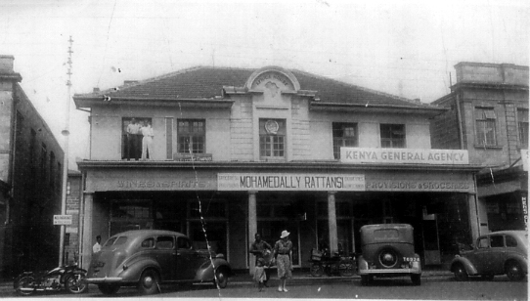
Shop in Nairobi (Moi Avenue)

The business in Nairobi prospered, with the astute assistance of Madatally Manji, who proved himself a born entrepreneur. Soon, Mohamedally summoned Hassanally to Nairobi to assist in the fast-expanding enterprise. Alas, his ideas and dreams of studying abroad were then quashed for good!

Retirement in Uganda

Hassanally increasingly assumed responsibility for the Nairobi store. Consequently, his father had the leisure for his many other interests. He became a patron and an active member of a society for the promotion of Gujarati literature and a number of other cultural organisations. He also expanded his business interests to Uganda by participating in a cotton-ginning venture in there. He became a partner with Mr. (later Sir) Eboo Pirbhai and Mr. Ibrahim Nathoo (later a Member of the Legislative Council and eventually one of the first non-European Ministers in the Kenya Government) in cotton-ginneries in Uganda. As his active presence in Uganda was necessary mainly during the three months of the ginning season, it let him free to cultivate his cultural interests in Nairobi.

However, he grew increasingly enamoured of Uganda. He greatly enjoyed his encounter with its lush vegetation, broad rivers, and raging cataracts. He had a great gift for making friends with people in all walks of life. He won the friendship of Ugandans of all races. A close friendship in particular, was with Mr. Muljibhai Madhvani, who established the great sugar works at Kakira and many other enterprises.

When in time Mohamedally disentangled from his ginning interests in Uganda, his thoughts turned to a large estate that he had fortuitously or providentially bought many years during his very first visit to Uganda, in the days of his partnership with Mr. Osman Allu. He had been offered a 640-acre freehold plot in Masaka, near Lake Bukakata, for Shs. 30,000, and surprised himself by buying it. It had lain undeveloped all these years. He decided that it would be the most fitting place for his retirement. He moved to it just before the end of the Second World War.

It did not, of course, prove to be an easy-going retirement. He began to grow papayas on a commercial basis for the extraction of the digestive agent pepsin. When the market in pepsin slumped, he grew tea on the estate and relished the challenge of clearing the land and planting tea. It was not an ideal site for tea growing as the rainfall was inadequate. He was later to say that it gave him far greater satisfaction than trade ever could, since he felt he was producing something where there had been almost nothing before. He enjoyed the long walks around the huge estate, the hard work it demanded, and the peace and contentment of evenings spent amidst a rural scene. He had the company of the many Baganda friends he made in the locality. He could indulge his passion for reading and continued his literary group activities whenever he came to Nairobi for a brief sojourn.

By this time, all members of the family were well settled in life. The eldest son, Haiderally, had a garage business in Uganda. Hassanally had sold the grocery business in 1949 and started a new one dealing in sporting goods, much nearer his own interests. Another son, Badrudin, ran the original Nyeri business, and Sultanally had joined his father at Masaka in Uganda. The youngest son, Pyarally, was completing his Ph.D. at the University of London. The two elder sons, Haiderally and Hassanally were also married and raising their own families.

Mohamedally Rattansi’s Ideals and Philosophy

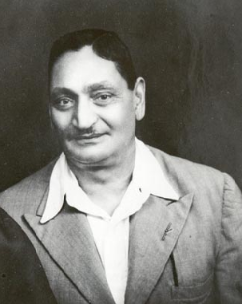
Mr. Mohamedally Rattansi (1882-1957)

Mohamedally’s fondness for the beauty of nature to date remains an abiding memory whenever the family remembers him. Nyeri’s setting was idyllic for him, surrounded by hills and forests with the peaks of Mount Kenya cascading majestically on the far horizon. It was in these beautiful surroundings that he conceptualised his own thoughts, ideals and philosophy.

He had a particular fondness for trees. He often reminded the family of the intricate analogy between human beings and trees - that human beings too, grew roots as trees did, and that like them, they constantly reached out upwards, as if seeking their Creator. He was a God-loving, rather than a God-fearing individual. Although an Ismaili, he believed in the ultimate unity of all religions.

Secure in the cultural identity that his traditional Indian background gave him, Mohamedally welcomed, at the same time, all that he could learn from the modern western world. He had a passion for technological innovations, which he shared with his eldest son, Haiderally. He installed an electricity generator many decades before the power lines reached Nyeri. He had an engineer sent from Nairobi to install a cinematography projector for the family. He was an early enthusiast of the motor-car, from the early purchase of a model T Ford to a natty Chrysler bought just before the outbreak of the Second World War.

He had passed his early life surrounded by the Wandorobo, the Wakikuyu, the Wakamba, and the Maasai. This experience impressed upon him the essential unity of humankind. His sympathy with the struggle for independence on the Indian sub-continent convinced him that only in a climate of freedom could human beings develop to their full capacities. He could not, of course, any more than other liberal-minded contemporaries at the time, foresee the rapidity of the changes, which would later bring his adopted country to the threshold of independence and nationhood in his own lifetime. He concluded that humane dealings with all, imaginative sympathy and affectionate interest in them, and an intelligent compassion would finally break down the barriers of tribe and colour.

He did not compromise his ideals of truth, honesty and integrity. The simple and noble principles he tried to follow throughout his life deeply influenced all members of his family. He taught them to try to live their lives in fullest harmony with their natural and social environment, free from petty prejudices of colour, race and religion. That was Mohamedally’s most valuable legacy to his children.

In keeping with the abiding cultural tradition of India, he strongly believed in dharma or final duty. He indicated that dharma places an obligation upon us to ‘pay back’, to the fullest extent we can, all that we owe to the society that has made it possible for us to mature and prosper. It is hardly surprising therefore that Mohamedally involved himself in social and charitable activities early in life.

Picture of Tumutumu Hospital Rattansi Ward

One of his first benefactions was at Tumutumu, not far from Nyeri. There the Church of Scotland ran a hospital - the only one in that area. Medical care was segregated, and a separate ward was reserved for each of the three racial groups. Asians could visit Tumutumu only as out-patients. There was no accommodation for them if it was necessary for them to spend a night in hospital. Mohamedally built an ‘Asian Ward’ there. It cost him some ten thousand shillings, equivalent to about half a million shillings today. This investment meant that he could not afford a new pair of shoes for the next four or five years (they cost 17/- a pair). One of his sons, Hassanally, could still remember him having his only pair of shoes resoled for several years!

Mr. Mohamedally Rattansi was an ardent diary writer and continued to maintain this throughout the rest of his life. Despite his limited schooling in his ancestral village in Kathiawar, his diaries are articulate, written in a script that is a delight to the eyes. His love, respect and thirst for learning were his driving force. He achieved a great command of literary Gujerati through his wide reading and love of the language. His journey in life made him realize that education was a key factor in every human being’s life.

Once they had decided to set up The Maniben and Mohamedally Rattansi Educational Trust, he narrated a very touching and spiritual summary of all these events in his Diary by remarking that he had by then spent 53 years in Kenya. It had been an extremely busy life, spanning many years in rural and wild forest regions. He had raised a progeny, with many children and grandchildren, and now was the time for him to return from whence he had been brought into the world. The shades of evening were falling, and night crept near. If he succeeded in accomplishing the most important tasks which still remained to be done by him, only then he could leave with the satisfaction that it had truly been a fruitful one and meet and merge into the great spirit which controlled the universe [‘jaga niyanta neh pamih shuh kaiv]. ‘The forests, the mountains, the green fields will endure the same for ever. For me it is time to bid farewell.’ [In Gujarati, ‘Jangalo, pahado, leela khetrero to temuj hasheh. Mareh toh haveh vidayagiri levih joiyeh.’]

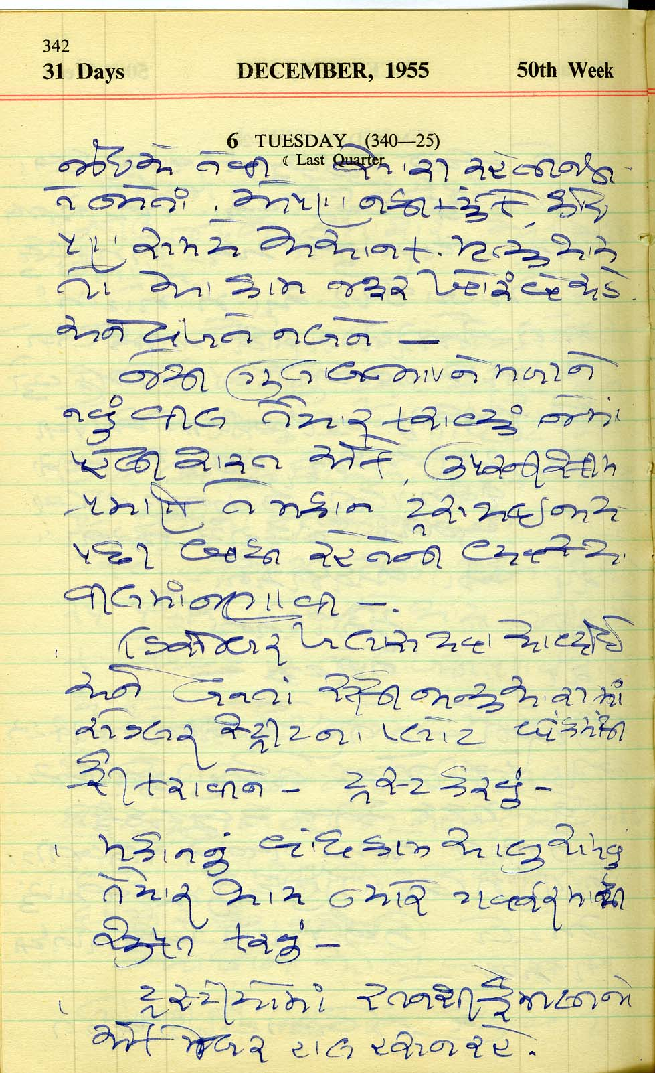
Excerpt from Mohamedally Rattansi’s Diary 1955

Dr. Hassanally Rattansi

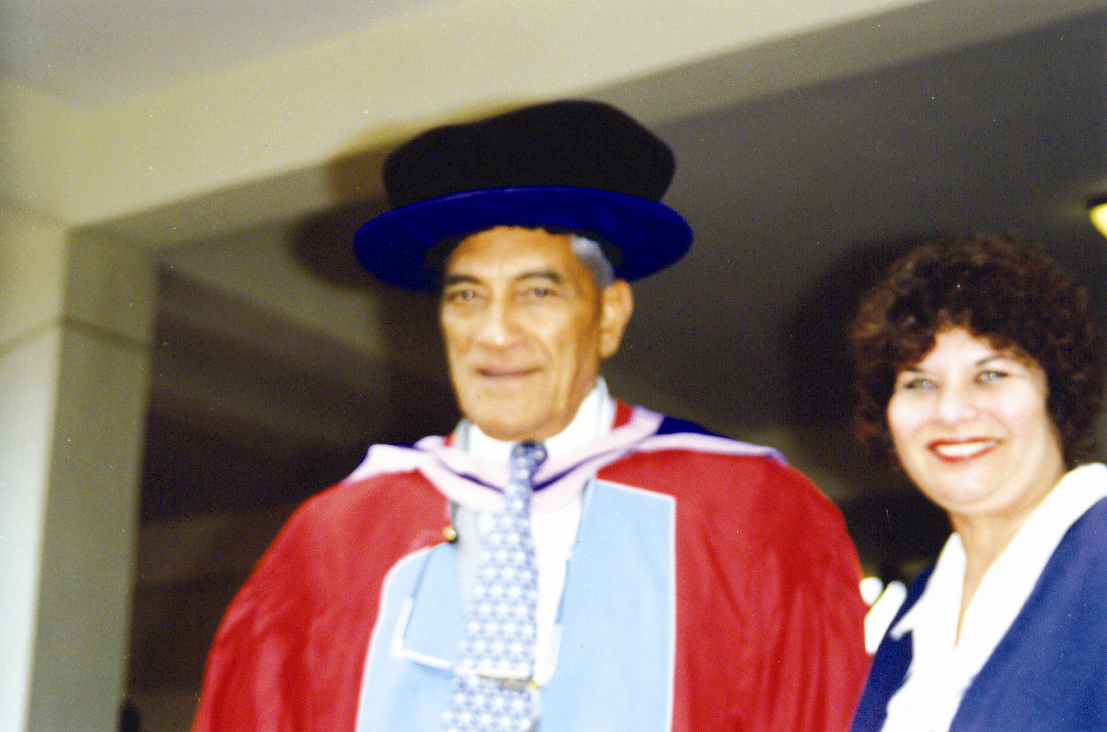

Dr. Hassanally Rattansi with his wife Mrs. Vijoo Rattansi after receiving an honorary doctorate at the University of Nairobi in 1998

Dr. Hassanally Rattansi was born in Nyeri, in a valley nestling between the Aberdares and Mt. Kenya on 14th March, 1921. He was the fourth child, in a family of ten, of Maniben and Mohamedally Rattansi. He started his early education in a makeshift school in Nyeri. In those days, the government made no provision for Asian schools in the rural areas. In small towns, such as Nyeri, Asians typically clubbed together to hire a teacher or two from India and set up their own school. More often than not, a leading merchant would make rooms available in his house for classes.

In 1931, Dr. Hassanally completed whatever schooling Nyeri could offer. He then enrolled in the government Indian Senior Secondary School, now Jamhuri High School, in Nairobi. He passed his London Matriculation Examination in 1936 and hoped to study medicine or pharmacy in the United Kingdom. However, his parents moved to Nairobi and left him and his elder brother, Haiderally, to look after their Nyeri business. This abruptly cut short his ambitions for further education.

From these humble beginnings, he developed an illustrious career as a sportsman, businessman, civic official and philanthropist. Over the years, he played a leading role in the development of sports in Kenya as a sportsman or sports administrator. He held various elected positions in sports organizations dealing with cricket, lawn tennis and badminton. For example, he was Chairman of the Asian Sports Association in 1962, and Kenya Lawn Tennis in 1965. He was also one of the founder members of the Kenya Cricket Association and served as its Treasurer in 1965, and the Kenya National Sports Council between 1966 and 1984. And between 1994 and 1997, he served as a member of the Central Executive Committee of the Kenya National Sports Council.

Equally, he ably represented Kenya in the international arena. For instance, he was player-manager of the first East Africa Cricket Tour of South Africa in 1957 and was also Team Manager of the Kenya table tennis team to Cairo in 1962, and lawn tennis team to the first African Games in Brazzaville in 1965.
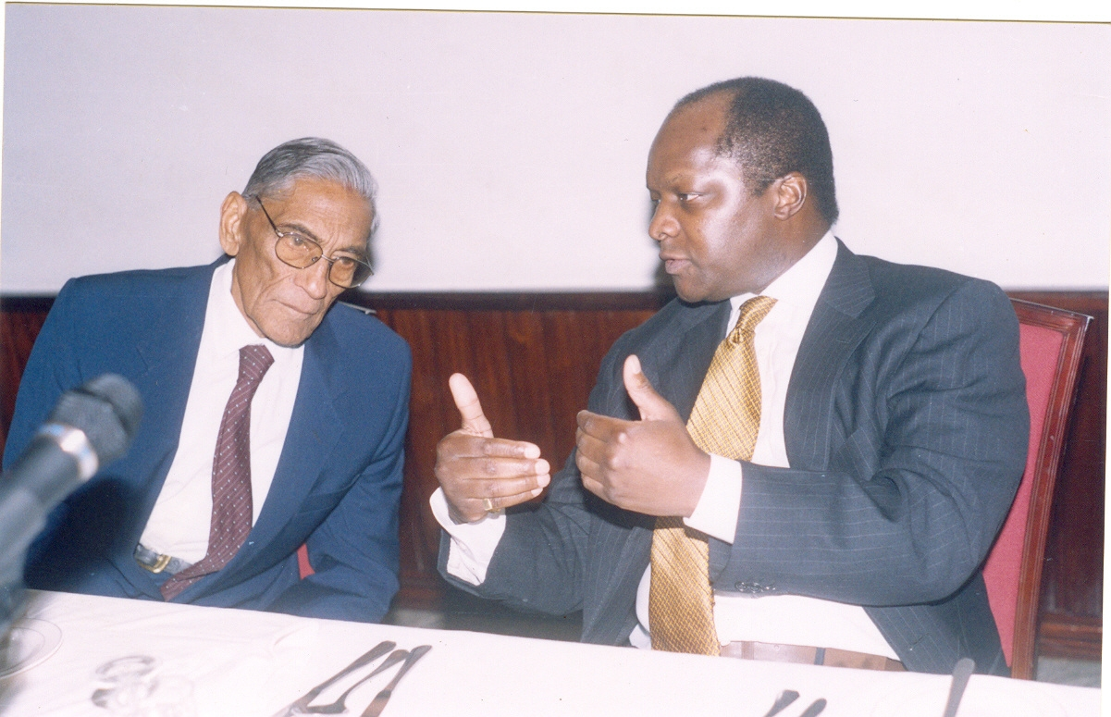
Dr. Hassanally Rattansi and Ronald Muwenda Mutebi II Kabaka of Buganda (2003)

His love for sports was exemplary. It is this life-long commitment to sports that led the Rattansi Educational Trust, of which he was a long-standing chairman, to offer financial support to a variety of sporting bodies as well as purchasing sporting equipment for many educational institutions.

Aga Khan Club Cricket Team, 1959-60 Season
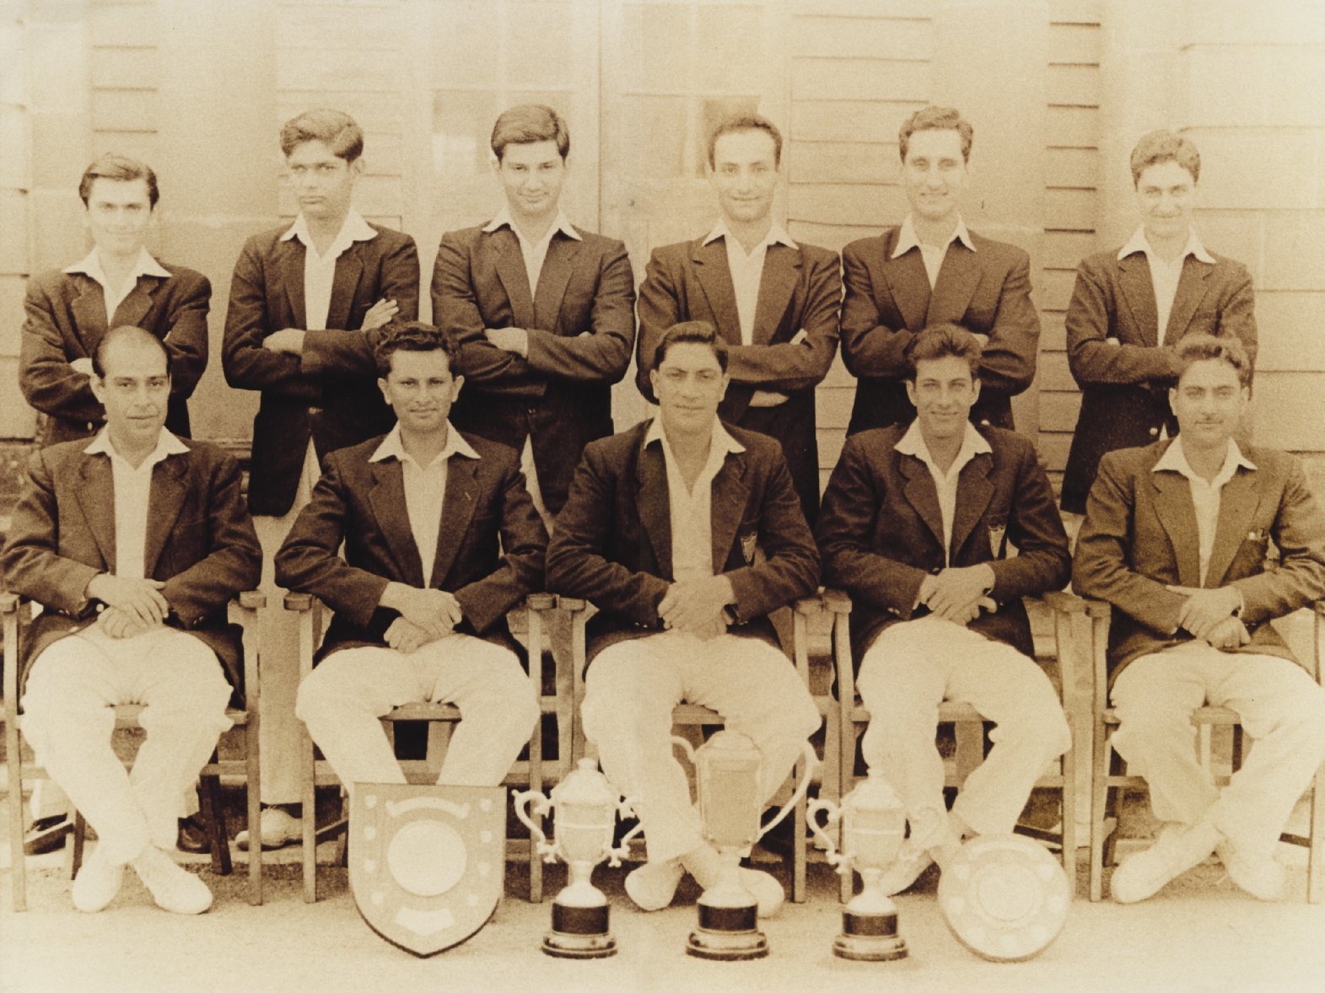
Standing left to right: Karim, Sidi, Kassamali, Noorali, Akbar, Salim
Sitting Left to right: Sherali, A. Sultan (Capt.), Hassan M. Rattansi, Aziz (Vice Capt.), and Hirani

His civic duties were multi-faceted. They included serving as a councilor in the Nairobi City Council (1960-65) and being the chairman of the board of governors of Highway Secondary School, Kenya High School and St Theresa’s Secondary School. He also served as a member of His Highness The Aga Khan Nairobi Provincial Council and Nairobi Hospital Board.

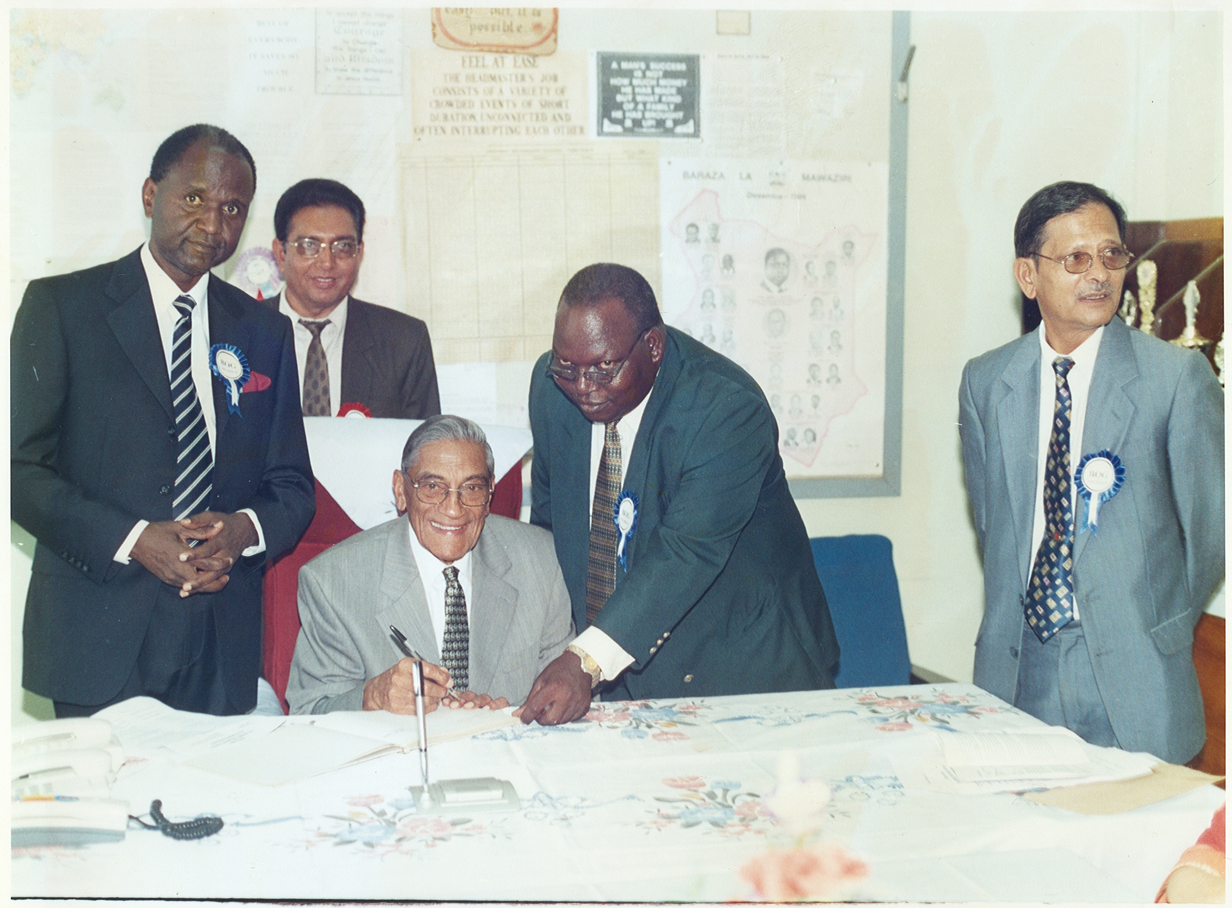
Dr. Hassanally Rattansi seated with Board Members of Highway Secondary School

Dr. Hassanally Rattansi took over the management of the Trust following the death of his father, Mohamedally Rattansi, on 28th July, 1957, and the Chairmanship in 1962. He devoted his life to administering and developing the Trust, and together with his wife, Mrs. Vijoo Rattansi, have made it into what it is today, 50 years later.

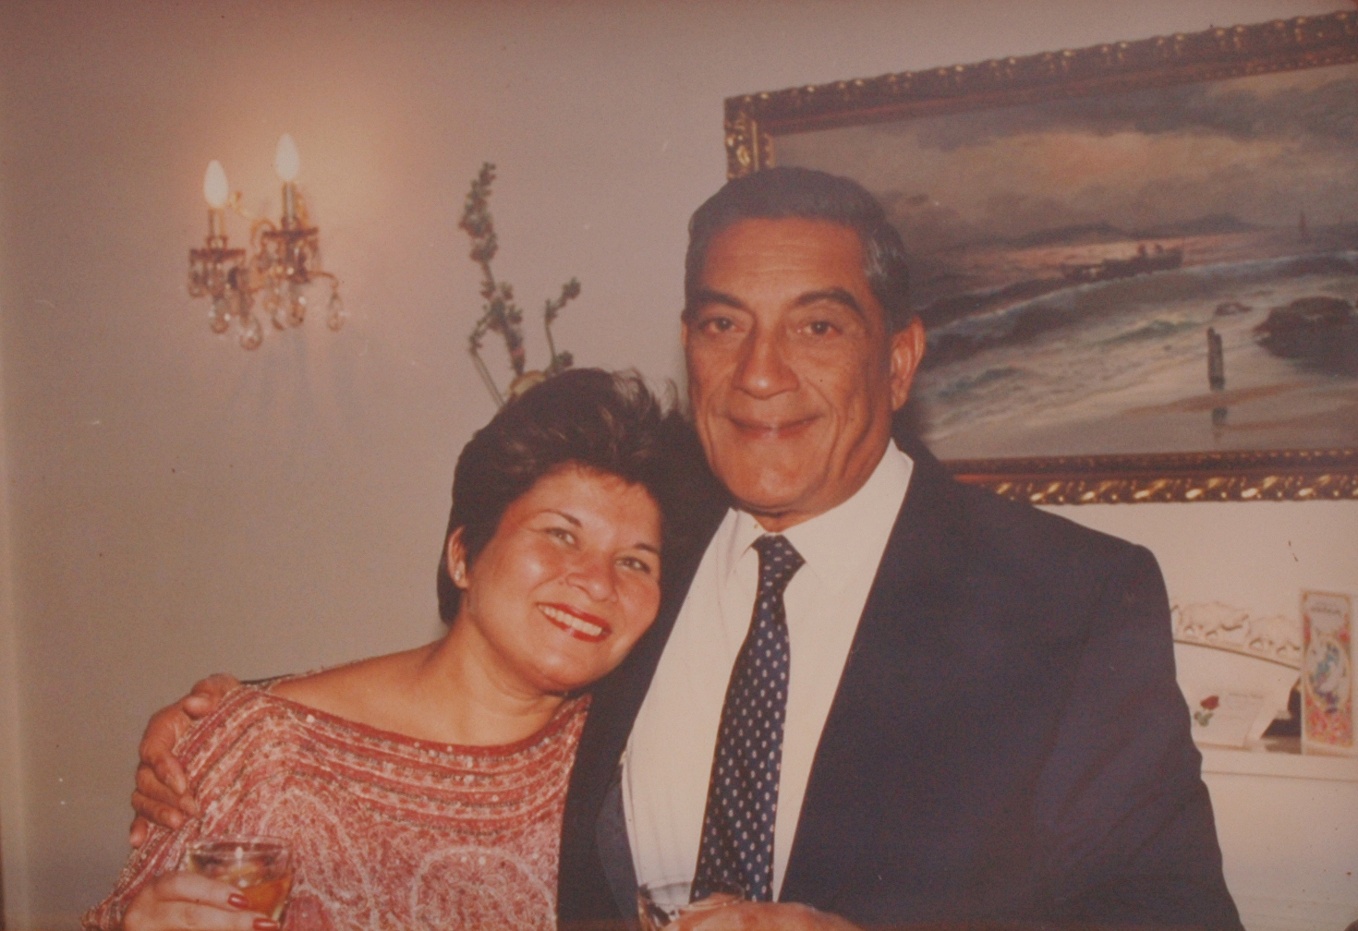
Dr. Hassanally with his wife, Mrs. Vijoo Rattansi

Asked by the Standard Life Magazine what success meant to him, Dr. Hassanally Rattansi responded: “To me success is what makes you feel that what you wanted to achieve and understand, you finally achieved and understood. That the achievement has brought you happiness and a sense of fulfilment.”

Dr. Hassanally Rattansi was not only a big-hearted man, but also a great humorist. His story would not be complete without including some quips and quotes captured during those light moments. The following is a sample of them, said during different occasions in his lifetime.

“Our greatest enemy is greed, which is the motivator of immorality, corruption and selfishness. We can’t remove it chemically through medicine but by education. Kenya needs moral education.”

“When my wife and I gave up the rat-race and sold most of our property, we became happier. If you are in the rat-race even if you win, you are still a rat. We must involve young people by example. That is why we have given up most of what we owned to the public.”

Differences, he says, are good “because this makes our culture a rich blend of a beautiful rainbow. We must work and live together.”

To improve racial relations, we have to rely heavily on education – with children going to the same schools “children have no prejudices. It is adults who teach them prejudices.”

According to Rattansi, politicians are the culprits as far as tribalism and racism goes. Kenyans and the media must create forums for challenging politicians. He regrets that “even sports pages in our newspapers are filled with articles on corruption, intrigue and the evil nature of man”

“We will never be able to get rid of poverty from the earth. Man is selfish by nature and it’s difficult to change that. The greed in us may reduce to acceptable levels though, if we discard arrogance and war.”

But he warns leaders and all those involved in evil schemes that every action has a reaction: “That is God’s unwritten law. Files don’t go missing in God’s Kingdom. Everything in the world is destroyable but you cannot destroy the truth.” Greedy and irresponsible leaders will eventually pay for their actions.

“My father gave me ample sense of humour. Without humour, life would be useless. Humour is the spice of life. Humour is a very vital ingredient of life. You should be able to laugh even at yourself.”

But Kenyans are lucky, he says, because people are still very spiritual. “For without love and faith, one is empty and useless.”

Hassanally’s love for sport was immeasurable. He also played cricket for Kenya. In his heyday in the Kenyan Cricket team he was one of the best wicket keepers. This has been witnessed is said by numerous friends and fans who watched him play and still talk about his amazing feats while keeping wickets.

In 1956, the Kenya Asian Cricket team was invited on a tour by the South Africa Cricket Board of Control to play in South Africa. Hassanally was player-cum-manager of the team. The team arrived in Johannesburg then wended their way through to Ladysmith, Pietermartzburg, Durban, Port Elizabeth, Paarl, Cape Town and then finally through Kimberley to Johannesburg and back to Nairobi.

When the team first arrived in Johannesburg, they were given a tumultuous welcome. A superb dinner party was held in their honour. All this in apartheid South Africa. The next day, the newspapers were full of this incredible reception given in honour of the visiting Asian team from Kenya. There was hue and cry all mingled with a lot of criticism and shock just because white waitresses had waited on “Asians”. This was not the done thing. A resolution was passed the same day that white waitresses should not serve these brown people again. At the next function, Hassanally, being as vocal as he was, gave his usual thank you address at the dinner for the visiting party. He delivered a very humorous speech which he summarized by saying, “thank God we have very pretty and pleasant coloured ladies serving us today. The other evening the white waitresses were so ugly that none of the food was palatable”.

He believed that helping others opened values for him. In order to effectively do this, he sold his own business in 1987 in order to devote his energies and talents to the Trust. Even before they sold the business, Hassanally worked for the Trust with a zest only he possessed and started to realize his parents, dream. He did this free of charge and on a daily basis for sixteen years, thus fulfilling his dharmic duty.

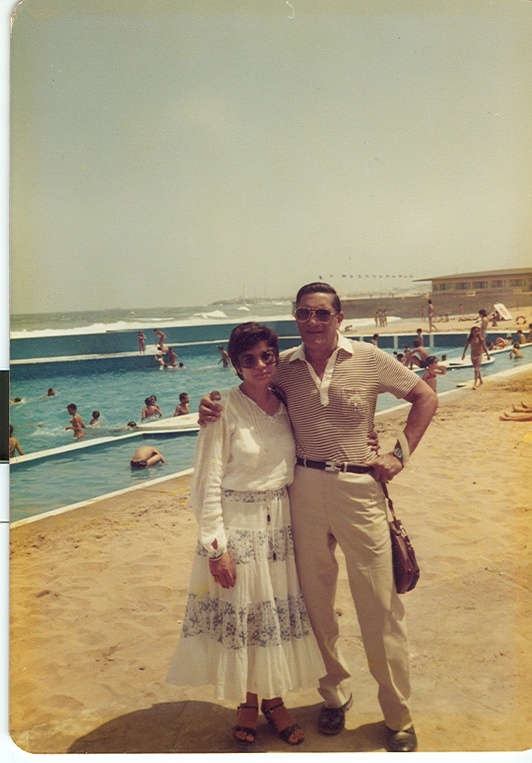
Dr. Hassanally with his wife Vijoo Rattansi in Morocco for a holiday

As a family man his children, brothers and sisters remember him with a lot of love and affection. His sister, Shirin, related the following with a lot of nostalgia “this must be when I was about 10 years old. I do not exactly remember. He got married in 1946 and I was born in 1932.

After closing the shop, he would go for a run and come home. He would first consume large quantities of oranges which he brought from the shop and which Roshan would peel for him. Even now when I eat an orange, I associate that fresh smell of oranges with Hassanalibhai! Then both Zarina and I would sit on each of his leg. Piyo would play the organ and we would all sing the latest film songs together. We went to see a movie every Sunday and when we returned from school on Monday, Baa (mother referring to Maniben M. Rattansi) would have been to Assanand’s in the morning to get the set of records from the movie. Zarina and I would hear the records a couple of times after doing our home work and sing them. This routine went on night after night until he got married!

At the start of the new school year, I would cajole him into writing my names in all the books because he had such beautiful handwriting! If I had any problem with my home work, he would patiently help explain it. He was so proud of me when I came home from school at the end of the term waving my school report because I had done so well! He would give me something little from the shop the next day.

With the Rattansi sense of humour, we were always laughing. Even at the table during dinner time, some story or the other was related with a funny angle when no one else could not see anything funny in it! This was true of every one in the family. Everyone saw some humour in every day occurrences, however mundane the occurrence!

If Zarina and I wanted something, we would hug him and say, Hassanalibhai with such affection, he would straight away come to the point and say, yes, what is it that you want?! We invariably got what we wanted.

I miss him very much and still dream of him often. May his soul rest in eternal peace.”
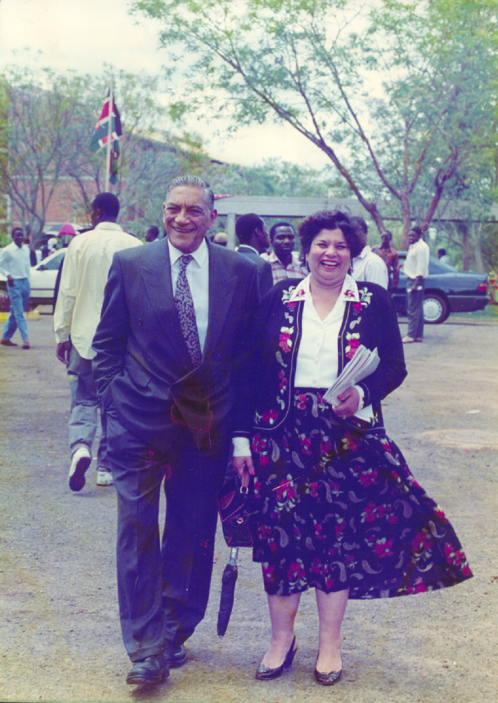
Dr. Hassanally with wife, Mrs. Vijoo Rattansi

Hassanally was a very caring, loving and generous husband, father and best friend all rolled into one. His family was his heartbeat. He loved all his children immensely but taught them to respect elders. He was not one to tolerate nonsense and although he was lenient, if his patience was tested to the hilt, as far as good simple manners and everyday discipline in life was concerned the disciplinarian in him came to the fore. He did not believe in the rod but always had a friendly but very firm chat with “the naughty one.” It always worked. Such a situation was very rare indeed.

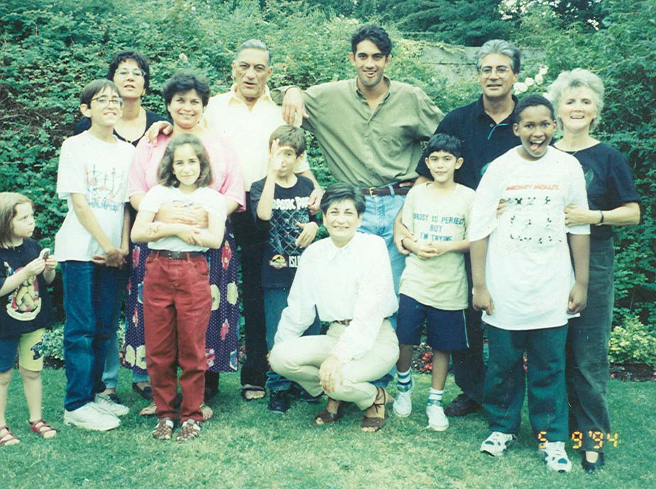

Left to right
Back row: grandson Richard, daughter Rehana, Vijoo Rattansi, Dr. Hassanally Rattansi, sons Riaz and Rafig, daughter-in-law Dorothy
Front row, granddaughter Leslie, grandson Nicholas, daughter Nadya, son Imran and grandson Marc

He spent a lot of time with the children who picked up all his good qualities, such as his love for all the beautiful things Mother Nature has created and his love and respect for the human race regardless of colour or creed. All this he usually did at bedtime story-telling. An amazing story teller, he created the most amazing tales on the spur of the moment, and narrated these with all the vivid details of his childhood memories about his life in Nyeri , with his parents, brothers, sisters and a lot other interesting people. His tales mesmerized not just the children but me too. When he spoke, one could actually visualize the events unfolding before his or her eyes.

If he was playing cricket or any other match the children were there watching their father play. While they were little toddlers it was toddler games. As they grew up it was tennis, squash and golf and just doing things together. His love for sport and his sense of humour have definitely transmitted into his five children.

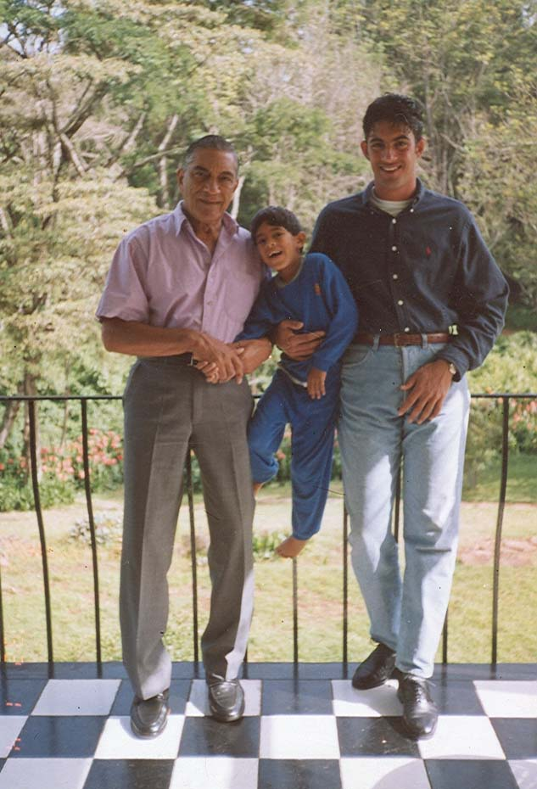
Left to right
Dr. Hassanally Rattansi and sons Imran and Riaz

In a few words, Hassanally was the ideal parent and husband. A man with his qualities is indeed a very rare find today.

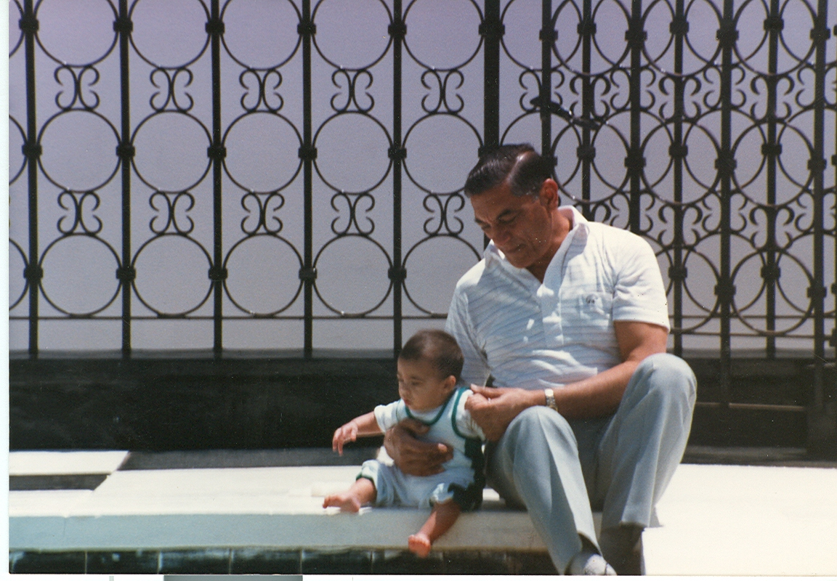
Dr. Hassanally with his youngest son, Imran

His unfailing sense of humour once came to the fore on the evening of Saturday 29th November 2003, the night before his departure from this earth. He looked at his youngest son Imran, and said to his, wife “the world will not be rid of me so easily. In Imran we have a carbon copy of myself, born on the same day, same time, but different years”. His famous hearty laugh followed that statement. Although his children and wife miss him tremendously, they also realize that they must follow the ideals he stood for and must celebrate his life at the same time because he drank deeply from the cup of life. The family feels fortunate, privileged and humbled to have been part of his very full and enriched life.

Curriculum Vitae of Dr. Hassanally M. Rattansi
Positions Held
- Chairman Rattansi Educational Trust
East African Grant Makers Association
Board of Governors, St. Theresa’s Secondary School
Kenya Lawn Tennis Association
Kenya Table tennis Association
Kenya Badminton Association
Muslim Sports Association
Aga khan Sports Club
Kenya Cricket Umpires Association
Lions Club (Nairobi Host)
Board of Governors, Highway Secondary School
Asian Sports Association
- Trustee The President’s Award Scheme (The Duke of Edinburgh's Award Scheme)
Kenya Cricket Association
- Member Kenya National Sports Council
Kenya High School
Nairobi Hospital
Presidential Probe Committee, Nairobi City Council.
Central Executive Committee, Kenya National Sports Council
H.H. The Aga Khan Nairobi Provincial Council
- Patron Nairobi Gymkhana

Awards
- Honorary Award by Nairobi Provincial Cricket Association Citation. "In appreciation of distinguished services to the game of cricket in Kenya." (1988).
- Honorary Degree; Doctor of Letters from the University of Nairobi at their Graduation Ceremony on 30th November, 1998. Citation reads, "in recognition of his contribution to philanthropic support for education, social justice and development of sports in Kenya".
- The Silver Star (S.S.) of Kenya by His Excellency President Daniel Arap Moi on the occasion of Kenya’s Independence Day Celebrations on the 12th December, 1998.
- Appreciation Award "in recognition of Distinguished Services." by Lions Club Nairobi-Host during the 1998-1999 awards.
- The Presidents Award, Kenya, "in recognition of outstanding service to the Presidents Award Scheme for young people" in January 1999.
- Aga Khan Sports Centre Appreciation Award for "Exemplary Service to the sporting fraternity" in October 1999.
- Honorary Degree; Doctor of Humane Letters of Kenyatta University during the 17th Graduation Ceremony on 18th October, 2002.

Selected to play cricket for Kenya: In inter-territorial games against Uganda and Tankanyika also visiting teams from abroad.

Player-Manager First East African Cricket Tour of South Africa, 1957.

Kenya Team Manager Tennis, first African Games, Brazzaville, 1965.

Kenya Team Manager and Delegate:
All Africa Table Tennis Championships, Cairo, United Arab Republic

Kenya Sports Council Delegate:
Afro-Asia Table Tennis Conference and Championships, Peking, China, 1971.

Kenya Sports Council Delegate : All Africa Games, Algiers, Algeria.

Tour Manager K.L.T.A Tennis Team to Ethiopia, Aden and India, 1965.

Establishment of the Mohamedally and Maniben Rattansi Educational Trust
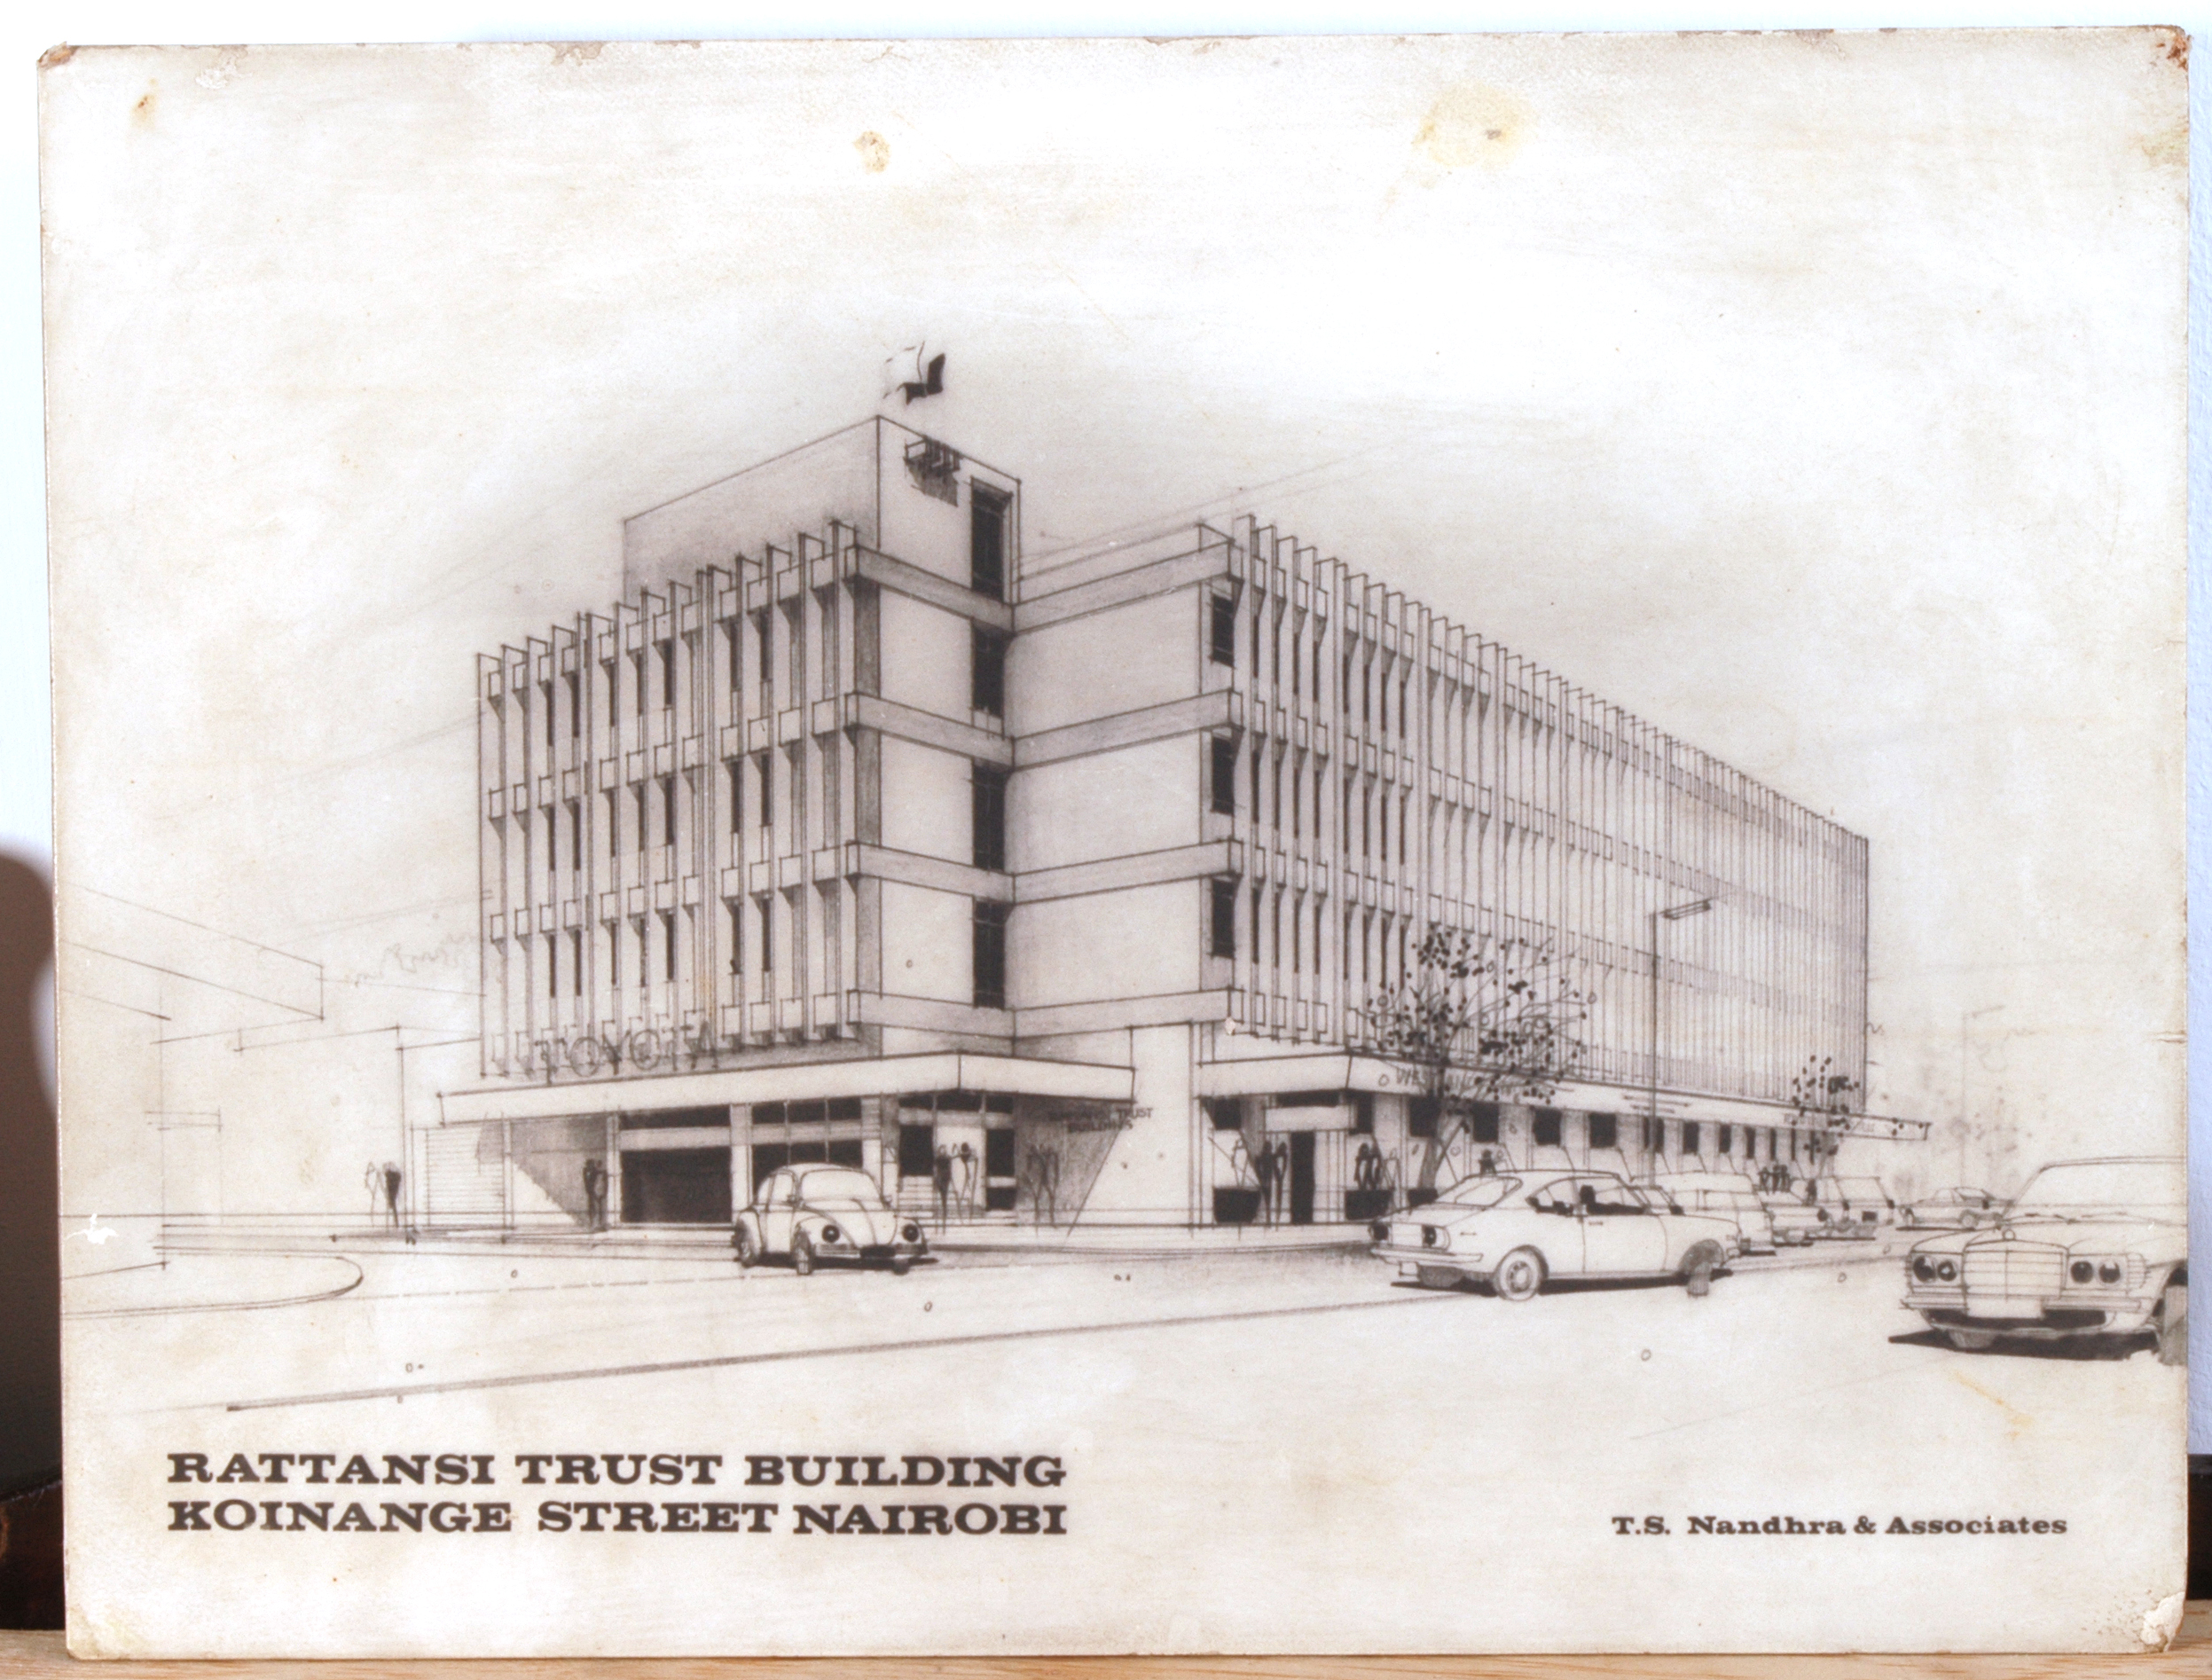

Rattansi Educational Trust Building

The idea of the Mohamedally and Maniben Rattansi Educational Trust is rooted in the ancient, cherished Indian tradition of Dharma, meaning final duty. This is a cultural obligation to repay in full, all that one owes to the society that has made it possible for one to mature and prosper. The moment had come for the elder Rattansis in the late 1950’s to reflect on their lives, now that they were contented and happy in Kenya as their chosen country. Their thoughts focused on the final duty that Dharma demanded of them. The year was 1956. Kenya was still a typical settler colony, divided along tribal and racial lines. The end of the war had unleashed forces that were rapidly changing the world. The attainment of independence in India was followed by that of many other countries and the winds of change were blowing over Africa, too.

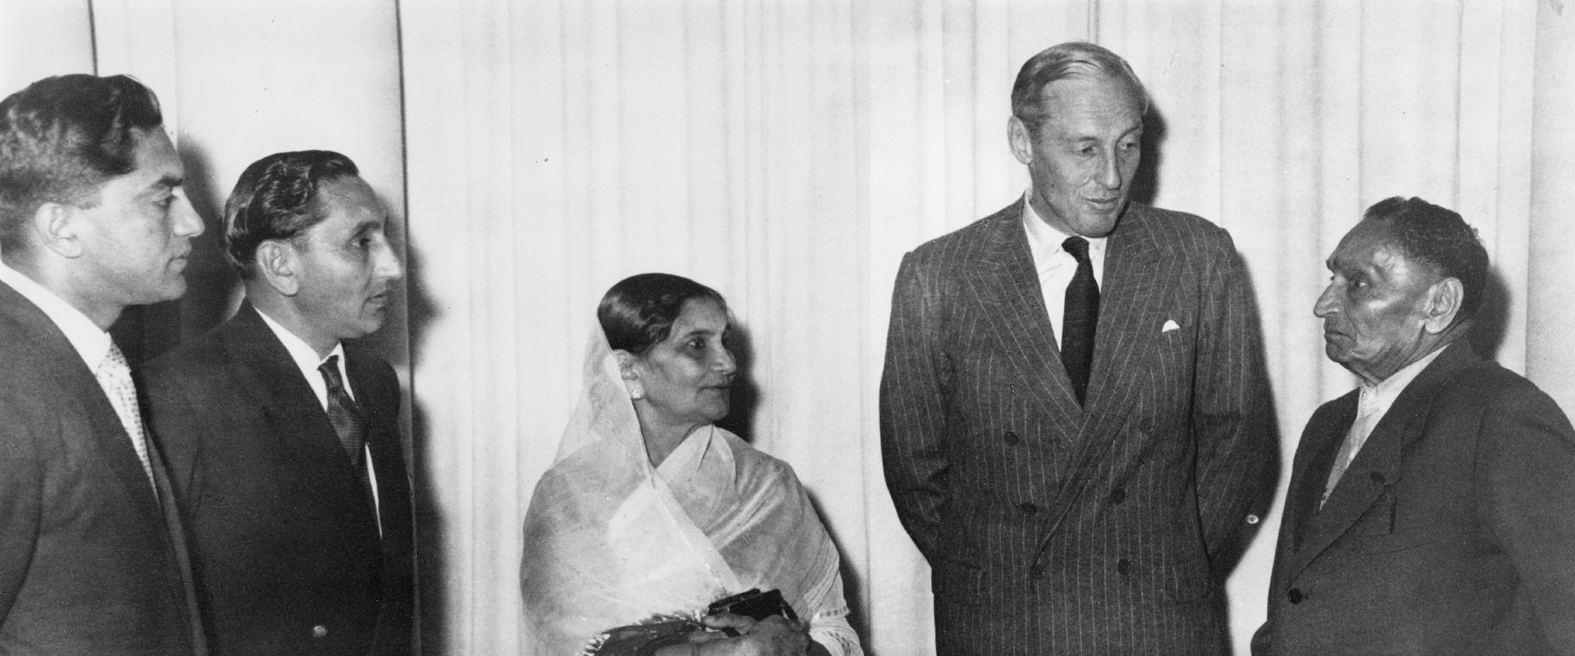

Left to right
Dr. Hassanally, Mr. Haiderally, Mrs. Maniben Rattansi, Sir. Evelyn Baring and Mr. Mohamedally Rattansi

The Rattansis rightly foresaw that as the freedom movement in Kenya gathered momentum, education would be vital for the advancement of both the individuals as well as of the emerging nation. Having risen from very humble beginnings themselves, they realised in full measure what it was like to struggle for an education to equip the individual for the challenges of life. Mohamedally Rattansi, therefore, foresaw the great need for education and established the Mohamedally and Maniben Rattansi Educational Trust to assist needy students.

With his mind set upon establishing a trust, Mohamedally summoned a conference of family members, together with a few of his close friends. He announced that instructions had been given to lawyers to prepare a trust deed bequeathing all three of the prime properties that he owned on Sadler Street (now Koinange Street) to the people of Kenya in perpetuity, and dedicated them to educational ends. The Maniben and Mohamedally Rattansi Educational Trust Fund Deed was thus drawn up and signed on the 17th day of September 1956. On the second of day of November, 1956, Mohamedally formally handed over the title deeds of the properties to the Governor of Kenya, Sir Evelyn Baring, at a ceremony in Government House, today State House, attended by many of Nairobi’s then notables.

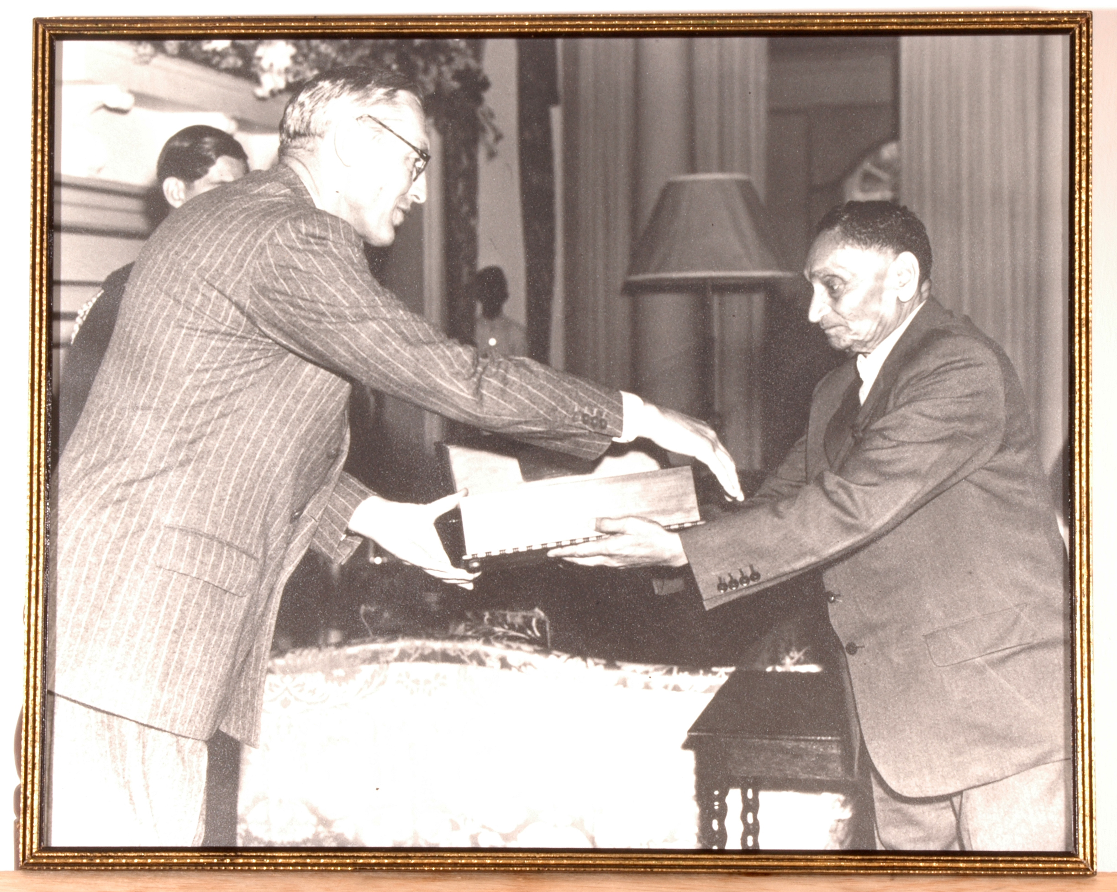

Right Mohamedally Rattansi officially handing over the title deeds of the property to the Governor of Kenya, Sir Evelyn Baring on 2nd November, 1956 at Government House Nairobi.

The first board of directors for the Trust ensured that all the different communities were fairly represented on the Trust. The Directors were, therefore, appointed from each of the five communities, besides the Director of Education of Kenya (or his nominee). They included the Founder, Mr. Mohamedally Rattansi, and his son, Dr. Hassanally Rattansi, Mr. John S. Wilkinson, the Hon. I. E. Nathoo, the Hon. A. B. Patel (soon succeeded by Mr. A. J. Pandya), Mr. Zafr-ud Deen and Mr. Wanyutu Waweru. The trustee was the Barclays Bank of Kenya.

Already stricken by cancer, an illness he bore with great fortitude, Mohamedally Rattansi passed away on 28th July, 1957. It was almost exactly a year to the day on which he signed the Trust Fund deed. The minutes of the Ninth Meeting of the Trust, held on 27th September, 1957 recorded that:

The Chairman [Mr. Ibrahim Nathoo] expressed his deepest regret at the passing of Mr. Mohamedally Rattansi, the founder of the Trust, after a long and painful illness and asked Mr. H. Rattansi to convey to his mother and her family the Board’s sympathies on the occasion of her tragic loss. The Director of Education added his expression of condolence. As a mark of respect to Mr. M. Rattansi all members present and those in attendance remained standing and observed a short period of silence.

Eight years later, the Minutes of the Board’s thirty-fourth meeting recorded the passing away of the Trust’s co-founder, Mrs. Maniben Rattansi, that:

The meeting stood in silence for one minute in memory of Mrs. Maniben Rattansi, Widow of Mohamedally and co-founder of the Trust and also Mother of the chairman, who died on 14th May, 1965.

After the new Act prohibiting Banks from being trustees, the new trustees became Dr. Hassanally Rattansi (until his death in 2003), Mrs. Vijoo Rattansi, Mr. Charles Njonjo and Mr.Robin Mason.

What is the Mohamedally and Maniben Rattansi Educational Trust?

Today the story of the Mohamedally and Maniben Rattansi Educational Trust is inextricably interwoven with the story of the life and times of Mohamedally Rattansi and his family. For fifty years now, any passer-by walking along Koinange Street, near the University of Nairobi, must have seen a four storey building bearing the words ‘Rattansi Educational Trust’ blazoned across its façade. The Rattansi Educational Trust is one of the leading charitable organisations supporting post secondary education and youth programmes in Kenya. It was established in 1956 as a result of the philanthropic thoughts of Mohammedally Rattansi and his wife Maniben Rattansi who strongly believed in social justice and the centrality of education in the advancement of individuals. From a single-storey building it is now a four-storey building.

Vision of the Trust
Education lights the path to development.

Aims and Objectives
In line with the Rattansis’ belief that education lights the path to development as expressed in the Trust’s vision, the main aim of the Trust is to get Kenyans out of the quagmire of poverty and help lift up their living standards. The specific objectives are:

- To assist in the provision of quality holistic education to Kenyans.
- To assist in the provision of a well rounded education for Kenyans to become good citizens.
- To offer bursaries for needy Kenyans at degree level.
- To assist Kenyans train in courses such as driving and dressmaking if this helps lift up family standards.

Benefiting all the People of Kenya

True to the founders’ ideals and beliefs, the Trust has educationally benefited all the people of Kenya. The Founders’ ideas and beliefs set the Trust radically apart from the few charitable trusts then in existence, which aimed at particular races or even individual sub-communities. As was expressly set out in the original Deed:

The name and income thereof shall be dedicated in perpetuity for the promotion and encouragement of the education of the following East African communities in the said Colony namely (a) European (b) African (c) Ismaili (d) Muslim and (e) non-Muslim [Asians]...

The income of the Trust Fund shall be applied in establishing and maintaining scholarships. . . with the object of promoting and encouraging studies at any university, college, school or other educational or training establishment approved by the Board . . . .

Each of the five communities was assigned 20% of the total income. Great care was taken to secure fair representation for the then most disadvantaged section of the population as portrayed in the composition of the Board of Directors of the Trust. The Minutes of a meeting in February 1957 stated that:

Mr. Nathoo [in the Chair] stressed it was of the utmost importance that the African member should attend on all occasions in order to safeguard the interests of the African community.

When Kenya attained independence in 1963 and all racial barriers began to be dismantled, the terms of the Trust, too, were altered to reflect the new situation. According to the Minutes of the 35th meeting, held in April 1965 it is indicated that:

Further consideration was given to the matter of varying the Trust Deed in the light of the changed circumstances since the Trust was set up and the secretary was requested to obtain the advice of the Trust’s lawyers on whether the Deed could be varied so as to permit all monies to be held in one Fund without a division between the various communities. . .

The lawyers concurred. After they had ironed out the legal technicalities, judicial application was made to alter the Trust Deed. In February 1967, the High Court of Kenya at Nairobi decreed:

The Trustee is hereby empowered . . . to apply the funds of the Trust without division between various communities . . .

At the same time, the terms under which the Trust operated were broadened. They now gave the Board freedom to support certain projects that, while not strictly educational in character, were in keeping with the original guiding aims of the Trust. The changes also made it possible for the Trust to borrow money in order to develop the property and generate greater income for the future.

The Trust has contributed to the education of many Kenyans. When it first started, the Trust could afford to send people abroad since those days it only required £250, per annum. However today, the training costs have spiralled and the Trust now restricts its funding to institutions in Kenya. Among the beneficiaries are Institutions and individuals. The institutions include all the public universities namely: Moi University, University of Nairobi, Kenyatta University, Jomo Kenyatta University of Agriculture and Technology, Egerton University and Maseno University. Other institutions include: Catholic University, United States International University, Machakos Technical College, Kenya Medical Training College, Mombasa and Kenya Polytechnics.

Indeed on April 23rd, 1996, the then Minister for Education, Hon. Mr. Joseph Kamotho, acknowledged the Trust’s very considerable contribution to higher education in Kenya in the following statement in Parliament:

“All the universities have set up active departments responsible for assisting genuinely needy students to get sponsorship from private bodies. I would, therefore, like to thank the Rattansi Educational Trust Fund, in particular, which is currently the leading donor in this respect, and to request other donors to join it in assisting students who cannot top up their fees for university education.”

On an individual basis, the Trust has contributed to the education of many prominent Kenyans. To mention just a few, they include: Raju Batavia (Batavia Enterprises Ltd., Mombasa), the late Justice J.M. Gachuhi (Court of Appeal), Mohamed Hyder (former Professor of Zoology and Principal, College of Biological and Physical Sciences, University of Nairobi), J.B. Karugu (former Attorney General), B.E. Kipkorir (former academic and Kenya’s ambassador to the United States) and Sadru Ramji (Wyco Paints, Nairobi). Many other individuals continue to benefit from the Trust.

Above all, the Trust is also instrumental in soliciting for support from different institutions and individuals for those who are in need. The Trust is further credited for inspiring some individuals in the society who have proceeded to establish Trust funds for the benefit of the needy in society.

Continuing Expansion of Trust Income
When originally deeded to the Trust, the property was a single-storey building, contributing a rental income of some Shs. 200,000/- per year. Over the years, the late Dr. Hassanally M. Rattansi spared no effort to develop the building. Today, it has been extensively re-developed and it is now a four-storey building, attracting a wide range of tenants. It contributes a rental income of about Kshs 17,000,000 per year, which is still rising.

During its first few years, opportunities for higher education were well-nigh non-existent in Kenya. The Trust granted bursaries to some ten to twelve students each year to study abroad, mainly in the U.K. and the U.S.A. The first bursaries were awarded at a meeting held on 5th June, 1957 at the Secretariat, Nairobi. The meeting awarded £1,455 to the first group of beneficiaries.

The numbers have vastly expanded over the years. In 1996 for instance, about 180 students were studying overseas with the assistance of the Trust. These students were in various universities in the U.K., the U.S.A., Canada, India, Pakistan, Europe, Australia and South Africa. Some 800 students were assisted with grants to study at various universities, polytechnics, technical colleges, computer schools and other institutions which now exist in Kenya. They too received approximately Kshs. 6,000,000/-. The total amount granted was in excess of twelve million Kenya shillings. It is noted that these impressive developments since the Trust was founded would have satisfied the fondest dreams of the founders.

The Trust has instituted a fully professional management. The Board of Directors takes all the decisions and Barclays Bank Investment Services Limited manages the finances. They collect all the income and make payments in accordance with the resolutions approved at Board meetings. Old Mutual Asset Managers handle all the investments for the Trust. The accounts are looked after by Mr. Jim Birnie, formerly of Coopers and Lybrand. All the Directors including the Director of Education, Kenya Government, who is an ex officio member, offer their services without any remuneration.

Picture of current directors

The very valuable contributions made selflessly to the development of the Trust by its various Directors, without payment or any special recognition, deserve to be placed on record. Their only reward is the knowledge that, through their efforts, they help hundreds of young Kenyans to live meaningful and independent lives to the benefit of their country and themselves.

Future of the Trust and of Kenya
As indicated in the Trust’s vision, the Rattansi family believes that education lights the path to development. In keeping with this tradition, the Directors of the Trust board have followed suit.

As we embark on the 21st Century, new challenges are continuously unfolding. Sixty per cent (60%) of the population of Kenya is under 18 years of age. Inevitably, demand for education is placing a very heavy strain on the resources of our country. It is also anticipated that with the current Government policy of free primary education, there will be an increase in the number of students joining secondary and tertiary levels of education. This will also mean that the number of those who will require support will rise.

What kind of education ought we, however, to promote? Not simply academic education to qualify for a profession, if we are to be true to the Founders’ intentions. The founders believed in what is now called holistic education, one nurturing an all-round development of the individual's full potential. Today, traditional ways and values are disintegrating. Venality and the unfettered pursuit of individual gain erode any concern for the larger public interest. In this stressful time, we need an educational programme that instils not only knowledge but civic responsibility, skills of leadership, team work, moral and spiritual values.

Sport, too, has a vital part to play in such an all-round development. Mohamedally used to say, ‘Your body is a temple for the spirit it harbours’. Sport is a great character-building influence and equaliser. Parental wealth and status counts for nothing in it, personal ability is all that matters. Given a fair chance the child born of the poorest parent can excel in it - as the laurels won by Kenyan sportsmen internationally have proved again and again. That is why the Trust supports such programmes as the Outward Bound Schools, Boy Scouts and Girl Guides, and the President’s Award Scheme (founded by the Duke of Edinburgh in 1956, coincidentally, the same year as the Rattansi Trust).

In keeping with the spirit of the ideals that inspired its founders, the Mohamedally and Maniben Rattansi Educational Trust has continually reshaped its policies to meet the varying challenges of education and development in Kenya. It is our fervent hope that it will continue to play a meaningful and substantial role in those fields into the next century and beyond, thus fulfilling beyond expectations the dreams of the founders Maniben and Mohamedally Rattansi, together with their son Hassanally Rattansi.

